WHY COMPLETE THIS WORKBOOK?
If you’re serious about going paperless or migrating from a legacy system, you first need a clear understanding of where you are and where you want to go. This workbook will help you achieve this first crucial step.
We’ve found great success with clients following the path outlined below. This workbook is the start to understanding and building a successful document management solution.

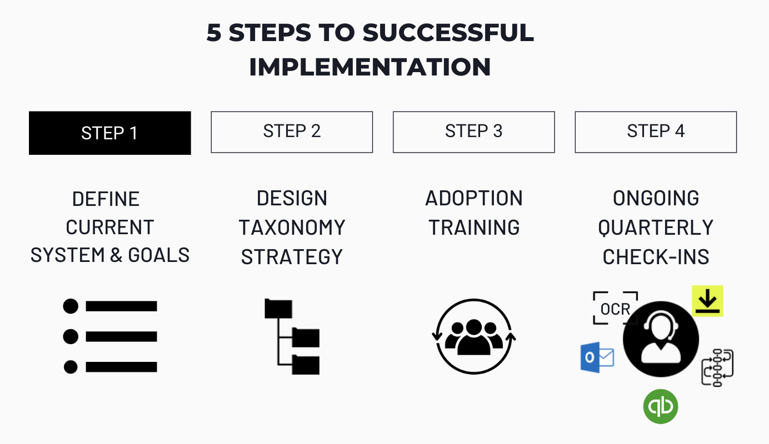

A PERSONAL APPROACH.
At DocuXplorer, we come with over 25 years of expertise and perspective on document management. You’re not only getting access to industry leading and time-tested tools but also the support to get you where you want to go.
Our team understands the complexities and resistance of adopting a new tool within your organization’s ecosystem. That’s why we’ve put so much focus on our hands-on consultative approach. It’s not just about the tools, but the strategy, application, education, and ongoing support that makes for a successful partnership.

We hope you find this exercise helpful and look forward to learning more about your goals.
LET’S GET STARTED:
1. Select your industry:
☐ Health/Medical ☐ Production/Manufacturing ☐ Financial ☐ Legal
☐ Government ☐ Human Resources ☐ Education ☐ Retail
☐ Other: Click or tap here to enter text.

2. What departments need help managing their documents? What is each department’s function?
Click or tap here to enter text.

3. Identifying Indexing Information (This should be completed for each department)
Tagging documents with indexing information or metadata is the cornerstone of Document Management and what enables you to quickly locate any record or trigger a workflow (a series of actions or tasks on a document.)
On the next page, you’ll identify the types of documents your organization uses and what information within the document is important for locating them easily.
For example, the accounting department processes thousands of invoices monthly. They can search for invoices by company name, invoice #, date, amount, or status. They also route invoices to different staff members for approval based on the billed amount. At the end of the week, they run a report to see all the invoices with the status “needs attention.”
For the exercise below, the document type would be invoice, and the indexing information would include Company Name, Invoice #, Date, Amount, and Status.

DIRECTIONS: Complete the chart below. The left column identifies the type of documents you work with. The columns to the right identify the index information needed to search for this record or trigger a workflow. These are samples to help get you started, rename the items in this chart to fit your department’s needs. We recommend each department completes a chart. If you’re unsure, we can help you with this process.
Document Type | Index Information
 | Name | Date | PO # | Invoice # | Billed Amount | Status
Applications | ☐ | ☐ | ☐ | ☐ | ☐ | ☐ | ☐ | ☐
Articles | ☐ | ☐ | ☐ | ☐ | ☐ | ☐ | ☐ | ☐
Checks | ☐ | ☐ | ☐ | ☐ | ☐ | ☐ | ☐ | ☐
Contracts | ☐ | ☐ | ☐ | ☐ | ☐ | ☐ | ☐ | ☐
Correspondence | ☐ | ☐ | ☐ | ☐ | ☐ | ☐ | ☐ | ☐
Credit Memos | ☐ | ☐ | ☐ | ☐ | ☐ | ☐ | ☐ | ☐
Drawings | ☐ | ☐ | ☐ | ☐ | ☐ | ☐ | ☐ | ☐
Invoices | ☐ | ☐ | ☐ | ☐ | ☐ | ☐ | ☐ | ☐
Medical Records | ☐ | ☐ | ☐ | ☐ | ☐ | ☐ | ☐ | ☐
Purchase Orders | ☐ | ☐ | ☐ | ☐ | ☐ | ☐ | ☐ | ☐
Quotes | ☐ | ☐ | ☐ | ☐ | ☐ | ☐ | ☐ | ☐
Receipts | ☐ | ☐ | ☐ | ☐ | ☐ | ☐ | ☐ | ☐
Reports | ☐ | ☐ | ☐ | ☐ | ☐ | ☐ | ☐ | ☐
Resumes | ☐ | ☐ | ☐ | ☐ | ☐ | ☐ | ☐ | ☐
Statements | ☐ | ☐ | ☐ | ☐ | ☐ | ☐ | ☐ | ☐
Timesheets | ☐ | ☐ | ☐ | ☐ | ☐ | ☐ | ☐ | ☐
 | ☐ | ☐ | ☐ | ☐ | ☐ | ☐ | ☐ | ☐

4. Where are documents currently filed?
☐ Local hard drive ☐ Filing cabinets ☐ Off-site storage
☐ Online storage ☐ Individual computers ☐ Other applications
☐ Email ☐ Other: Click or tap here to enter text.

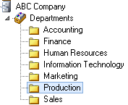
5. How are documents currently filed?
Providing an example like the one to the left will give us a clear understanding of how your organization files and stores documents. This helps us create the proper structure for your organization in DocuXplorer. If you are unable to create or supply an example, no need to worry, we will help you design it.

Click or tap here to enter text.

5. Beyond the immediate objective of converting to a paperless office or organizing your electronic files, what additional business process improvement goals are you looking to achieve?
☐ Trigger automated processes like approvals and reminders
☐ Send documents for digital signature
☐ Automate the indexing and filing process of documents
☐ Schedule reporting on document activity
☐ Monitor email accounts, folders, and online storage to automatically add and index records
☐ Comply with government regulations
☐ Implement an audit trail
☐ Secure access to documentation (to only specific employees, departments, etc.)
☐ Access documents remotely
☐ Integrate with other software applications
☐ Other: Click or tap here to enter text.
NICE WORK!
You now have a blueprint of the documents you currently work with, how to locate them, and how they’re organized.
In STEP 2, we’ll build a new system of organization and map your existing records to the new structure.
Click the button below to meet with a DX advisor. If you’ve completed this form, please share it with allie@docuxplorer.com for a more informed consultation. If you haven’t filled out the form entirely, it’s not a problem. We can assist you with next steps.
SCHEDULE STRATEGY SESSION

